Architectural Review Checklist

Grid Summary Service (GSS)
1.1

Revision Document History
Date | Version | Description | Author
03/05/10 | 1.0 | First draft | Chris Piepenbring
04/05/10 | 1.1 | Updates from ARC review comments | Konrad Rokicki  Chris Piepenbring
Table of Contents
Introduction 4
Purpose 4
Guidelines for Completing the ARC 4
Project Details (To be answered by development team) 4
General Information 4
Architectural Details 5
Performance Requirements 7
NCICB Project Dependencies 8
Configuration Management Details 8
Additional Notes 9
System Requirements (To be answered by both development & systems team) 9
Operating System 9
Software (Technology Stack) 9
Server Hardware 9
Storage 9
Load Balancing/Fault Tolerance 9
Networking 9
Additional Notes 9
Proposed NCICB Deployment Environment (To be answered by systems team) 10
Hardware 10
Technology Stack 10
File Server 10
Database 10
Networking 10
Other Resources 10
Impact Assessment (To be answered by systems team) 10
Overview 10
Cost 10
Timeline to implement 10
Additional Notes 10
Acceptance 10
Appendix 1 - Future Systems Requirements 11

Introduction

Purpose
The purpose of the Architectural Review Checklist (ARC) is to help identify the deployment environment (both hardware and software components) necessary for an application to execute optimally within the NCICB IT infrastructure. The ARC is considered to be a dynamic artifact for any NCICB project and should be maintained in the configuration library (i.e. SVN) for each project. For new projects, this document template will be automatically checked into the projects repository by the SCM team upon project initiation. The ARC should be reviewed on at least a quarterly basis to capture any application design changes that may effect the deployment environment necessary for optimal performance.

Guidelines for Completing the ARC
The ARC is divided into 4 main sections. The first section (Project Details) is meant to capture general information about the project. The project development team should fill out the Project Details section and return it to the systems team. The second section (Systems Requirements) is meant to capture details of specific system requirements for the project. Both the development and system teams will preferably answer the Systems Requirement section jointly. However, depending on the development team’s familiarity with the NCICB infrastructure, they may choose to answer either all or parts of this section on their own. The third section (Planned Deployment Environment) specifies the proposed deployment environment for the application and is to be answered by the systems team based on the response to section 1 & 2. Finally, the last section (Impact Assessment) describes the impact (additional hardware/software costs, staffing resources…) to the existing NCICB IT infrastructure in order to support this application. Upon completion of the Deployment Environment and Impact Assessment sections, the systems team will return the ARC to the development team for final review and comments.

Project Details (To be answered by development team)

General Information

Project Description
The mission of the Grid Summary Service (GSS) is to provide support for caBIG mobile applications through a centralized repository of data about available Grid Services and a simple query capability utilizing caB2B. GSS exposes a set of services through a simple REST API rather than a standard Grid Service to allow ease of access to mobile platforms that do not currently support Grid Client APIs (e.g. iPhone). In the longer term, GSS can expand to support mobile web applications or other non-mobile applications that require similar functionality.

Contact Information
Title | Name | Phone | Email
Project Sponsor | Juli Klemm | 978-443-2431 | klemmj@mail.nih.gov
Architect | Chris Piepenbring | 703-835-3632 | piepenbringc@mail.nih.gov
Development Lead | Konrad Rokicki | 301-451-2234 | rokickik@mail.nih.gov

Major Deployment Milestones
Milestone | Date
Planned Release to QA | 4/15/10
Planned Release to Staging | 4/26/10
Planned Release to Production | 5/2/10

Architectural Details

High level architectural description:
GSS consists of a single web application that locally periodically queries the caGrid index service and the CBIIT caB2B instance to retrieve information about the type and location of all active Grid services and which of these can be queried through caB2B. This data is queried by caB2B mobile applications (at this time, only the caGrid iPhone App) through a REST API. The data is cached at GSS for better performance on these queries.

In addition, the GSS REST API provides a keyword search service that relays the search request to the caB2B REST API and awaits results. As these searches can often take a long time, the results are stored at GSS and relayed to the mobile application when available. This frees the mobile application to perform other operations while the search continues in GSS “in the background”.

Local storage is limited to caching of caB2B search results, caGrid service information, and miscellaneous client management data. This data is stored in a MySQL database through Hibernate. The majority of data access code is automatically generated through the caCORE SDK.

High Level Design Diagram (If available):

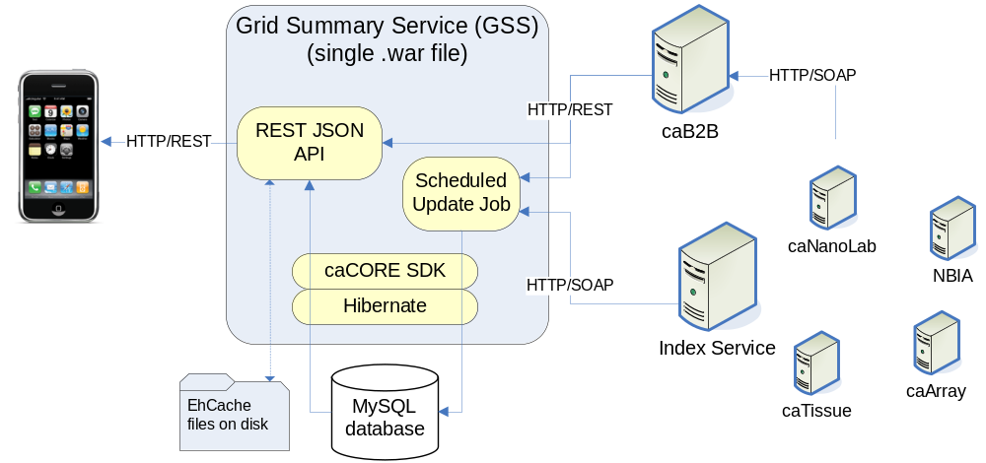

Implementation language(s) used?
Java 1.5

Will connections/requests to the application be session based (i.e. statefull versus stateless)? If so, is there any reason why application would not support “sticky session” load balancing?
The application does not use traditional webapp sessions. It uses unique device identifiers (e.g. iPhone UUIDs) to track results of asynchronous queries. Query state is maintained in an EhCache file. The application could not be load balanced across multiple servers unless this aspect was specifically addressed.

Will the application be caching data? If so, what is being cached and how much data will be cached?
As stated above, GSS will cache data retrieved from the caGrid Index Service and from caB2B queries launched from mobile applications. This data is stored in a local MySQL database and is held for retrieval by mobile applications.

caB2B query results are held in a disk-based EhCache until retrieved by the client that launched the search. caGrid Index Service information is cached and updated from the Index Service every hour.

Small amounts of data, such as JSON fragments, are cached in memory for faster data serving.

What data files will be created (if any)? How much data will be saved on an on going basis?
GSS stores several dozen small icons for presentation on mobile devices. These are kept in a file store directory but are small (< 5MB total) and do not grow dynamically unless explicitly added as an upgrade to a new release of GSS.

GSS also caches the results of user queries in a disk-based EhCache. This data is expired on a regular basis and is not expected to exceed 1 GB.

Like any caCORE SDK-based webapp, GSS also has a Hibernate cache that may potentially grow to several dozen megabytes.

Will this application need a database schema(s) created on the NCICB infrastructure? If so, what is the maximum number of objects to be stored?
Yes. GSS requires a database for information about available services on the grid.. This should not exceed 5 GB depending on number of users and searches processed by the system.

Are there any external/non-NCICB data sources that will be accessed by the application?
Not currently. All remote data will be accessed through the caGrid Index Service and caB2B.

If this is a web-based application, what are the preferred virtual hosts names to be registered?
gss.nci.nih.gov

Any additional architectural details that may be of significance to the needed deployment environment.
GSS is dependent on non-SSL communication with an active instance of caB2B. The URL to the caB2B server is configured during the GSS build process.

Performance Requirements

Total number of users for this application?
1000

Peak number of concurrent users?
50

Peak number of requests/minute?
50

Up time requirements?

Same as caB2B

Acceptable down time when recovering from major systems disaster?

Same as caB2B

NCICB Project Dependencies
GSS has dependencies on caB2B and caGrid 1.3.
Note that these are runtime dependencies where data is being queried across servers, not a direct dependency where one application must be installed locally with the other.

Configuration Management Details
Briefly describe your current configuration management practices here.

Version Control
What version control software are you currently using, if any?
GSS is using the gss SVN project on ncisvn.nci.nih.gov.

Change Control
What are your current change control practices? What procedures are in place to determine whether to implement a change request?
Enhancements and defects are entered into the GForge tracker. The project CCB meets as needed to determine which requests will be addressed. Approved requests are scheduled into an iteration and build, and then they are assigned to the development team.

Migration to CVS
Indicate whether you will require SCM support migrating your source code to the NCICB CVS repository.
No, using SVN. Repository was created by Sarah Elkins last summer.

Users
Provide a list of all developers who require access to your repository modules.
Konrad Rokicki, Jim Sun, Chris Piepenbring

Build Process
Describe your build process here. For example, are you using Ant, Make, or something else?
A caCORE SDK ant script is used to build the GSS application WAR file, which is deployed into a JBoss container.

Other CM Needs
Describe any other CM needs?
None.

Additional Notes

System Requirements (To be answered by both development & systems team)

Operating System

RedHat Enterprise Linux (64-bit preferred)

Software (Technology Stack)

Web Server: Apache 2.x

App Server: JBoss 4.0.5

Database Server: MySQL 5.1

Other software components: None currently

Server Hardware

Server: Standard VM configuration is fine

Minimum processor speed: Standard VM configuration is fine

Minimum memory: 4GB (if 64-bit), 3GB (if 32-bit)

Minimum local drive space: 20GB

Storage

Expected file server disk storage (in MB): 2000MB, may be local rather than on file server

Expected database storage (in MB): 5000MB

Expected ftp storage (in MB): None currently. May use FTP later for update of icon images

Expected media/image storage (in MB): 10 MB.

Load Balancing/Fault Tolerance

Does the application support load balancing?

No.

Networking

Any application specific port assignments? No

Any additional configuration? No

Additional Notes

Proposed NCICB Deployment Environment (To be answered by systems team)

Hardware
<<dev, qa, staging, production servers to be used>>

Technology Stack
<<specific technology stack to be used>>

File Server
<<space allocation on big IP, NFS mount points, initial size allocation…>>

Database
<<database server to used, schema names to be created, initial size, maximum size…>>

Networking
<<e.g. any BigIP configuration necessary, …>>

Other Resources
<<e.g. ftp server access, media server access, …>>

Impact Assessment (To be answered by systems team)

Overview

Cost

Timeline to implement

Additional Notes

Acceptance
Project Lead ( ) | Project Coordinator – NCICB ( )
Systems Team | SCM Administrator

Appendix 1 - Future Systems Requirements
In this section, describe any projected future anticipated requirements for your system.
- May require additional storage to temporarily cache DICOM images retrieved from NBIA
- May require HTTPS/SSL support if Grid logins are supported in the future

